1. Evaluate the following:

1(a). Convert to hex: 11001001.10112 =

1(b). Convert to decimal: 110101.012 =

3(c). Convert to binary: 98.2510 =

4(c)Convert to decimal: 2A.416 =

5. (d)find 110010 /110

6.(e)find 101011/100

7.(f)find 11001101-1110011

8.(g) find 101111-111111

9. (h)find 12-24 using 2’s complement addition

10.(i)find 1110011-11111111 using 2’s complement addition

11.(j)find 1101101*110011

12.(k)find 10011*111100

2. Write the Boolean expression equivalent to the following logic circuit. Do not simplify



3. Draw the logic circuit realization of the following Boolean expression as stated. Do not simplify! You may draw inverters explicitly or use inversion bubbles, as you choose.



4. Write the complete truth table for the Boolean expression of question number-3 and 2

5. Convert the Boolean equation of 3 to its DeMorgan equivalent.

6. Draw the logic circuit for the DeMorgan equivalent Boolean equation you found in 5. You may use inverters or inversion bubbles, as you choose.

7. Simplify the following Boolean expression as far as possible, using the postulates and theorems of Boolean algebra.



8. Simplify the following expression using the postulates and theorems of Boolean algebra. Eliminate all group complements. Justify each step by stating or referring to the Boolean theorem or postulate you use. Don’t skip any steps! Hint: De-Morgan’s theorem!



**Problem 1:**  Write a boolean expression for the output, Q, in terms of the inputs A, B, and C.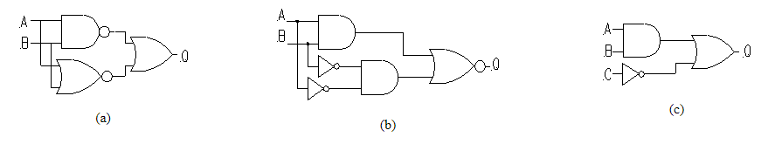

**Problem 2:** Draw a circuit to realize each of the expressions using AND gates, OR gates and Invertors.

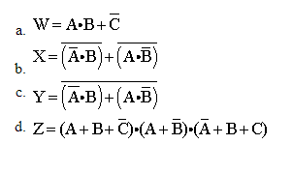

**Problem 3:** realize AND,OR,NOT,XOR,XNOR using NAND gate only

**Problem 4:** realize AND,OR,NOT,XOR,XNOR using NOR gate only

**Problem 5:**

**3.PNG**

**Note:**

**1. Students can sit in groups to solve this (maximum 3members in a group). But everyone should submit the answer individually.**

**2. After completing the answer every student should send the scanned copy(you can use camScanner app) to** [**Akhil.k@inurture.co.in**](mailto:Akhil.k@inurture.co.in)

**3. All the problems are supposed to finish in the lab hours only.**

**If any quires please attach with your mail.**

**4. Separate marks will be provided for this assignment.**

**5. The final date of submission will be at 5pm on your respective lab dates.**